**🔹 DTO (Data Transfer Object)**

Yeh wo class hoti hai jo **client aur API ke beech data transfer** karne ke liye use hoti hai. Yeh sirf wohi fields rakhta hai jo client ko chahiye hoti hain — extra data nahi.

**🔹 Domain Model**

Yeh wo class hoti hai jo **actual database structure** ko represent karti hai. Isme poora business logic aur database mapping hoti hai.

**✅ Real-World Example**

**🏦 Bank App**

Agar client ko user ka **name aur balance** chahiye:

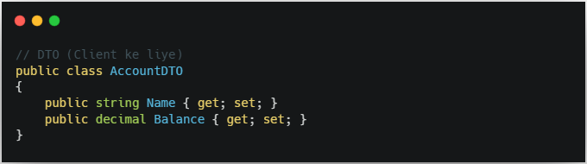

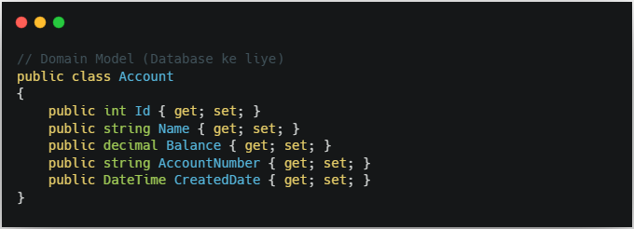

**📦 Flow Diagram (Image ke according)**

**Client ⟶ DTO ⟶ API ⟶ Domain Model ⟶ Database**

👉 API ke andar aap DTO ko Domain Model me map karte ho (e.g., AutoMapper use karke)  
👉 Isse **security**, **performance**, aur **clean architecture** maintain hoti hai.

**🔚 Final Notes**

* 🔒 **Security**: Domain model expose nahi ho raha — good!
* 📤 **Clean**: Client ko sirf zaruri data mil raha hai.
* 🧱 **Scalable**: Aage jaake AutoMapper ya services layer add kar sakte ho.

**Random**

